EuroBank

exhibit 2.2

Service Desk

Table of Contents
1. SPECIFIC APPROACH TO INCIDENT MANAGEMENT 1
1.1 Incident Tracking System 5
1.2 Communication and Notification 6
1.3 Escalation 7
2. REQUEST MANAGEMENT 8
3. SERVICE DESK SUPPORT 9
3.1 General 13
3.2 Call Management 14
3.3 For All Calls 15
3.4 For Calls that relate to the Services 15
3.5 For Calls that do not arise from or relate to the Services 16

- SPECIFIC APPROACH TO INCIDENT MANAGEMENT
The 2IM will have responsibility of the Incident Management, while the process management function is taken up by the Service Desk. All other Bundles will act as process executors. To support the effective resolution of Incidents the PST Supplier will implement a common Incident Management process based on their experience with ITIL, although individual PST Supplier’s Resolver Groups use their own resolution processes and tooling.

The operational management of the Incident Management process is performed by the Service Desk. In the as is situation the Service Desk uses the current EuroBank Service Desk system and database. Through Continuous Improvement and Business Case management the Service Desk, in full cooperation with 2IM and the PST Supplier’s Resolver Groups, will transfer to the standard PST Supplier Service Desk management system.

The Service Desk performs a dual role in the process. Next to being process manager, it also has a role as process executor: the call handling sub-process, the 1st line incident resolution, and the dispatching to the 2nd and 3rd line.

Process

The process for Incident Management is presented below:

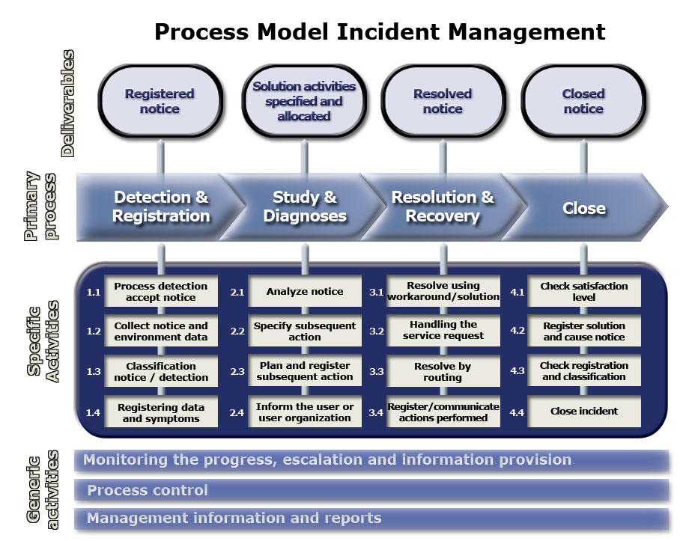

The Service Desk provides a single point of contact for the resolution of all incidents. An Authorised User can initiate an Incident either by initiating a Service Request over the Internet via the Self Service Portal, by directly calling the Service Desk or through e-mail and voice mail. The Self Service portal, Service Desk support, includes access to knowledge base engines that enable end users to quickly resolve their own incidents. Self-ticket entry allows Authorised Users to enter, cancel, or review status of their cases.

The Service Desk tracks and traces all Incidents as defined by 2IM. Logging will be done on details of the Incident, either received by telephone, Self Service Portal, fax or e-mail and categorise the relative importance of each incident according to urgency, impact and priority levels. All Incidents will be assigned one of four possible priority classifications as defined in Attachment 3E. These classifications range from 1 to 4. The priority is calculated automatically using the impact and urgency codes. The following table is used to identify the relevant priority code number:

Priority |  | Impact
 |  | High | Medium | Low
Urgency | High | 1 | 2 | 3
 | Medium | 2 | 3 | 4
 | Low | 3 | 4 | 4

Service Desk analysts will perform proactive and reactive troubleshooting to effectively identify Incidents and to provide a quick resolution, if necessary by taking remote control of a user’s desktop or dispatching calls to appropriate EuroBank Resolver Groups, the PST Supplier Resolver Groups, and/or Third Party Resolver Groups. The PST Supplier will use input from other Resolver Groups (e.g. LAN monitoring systems) to minimize occurrence incidents being reported by EuroBank business units, by proactively informing users.

The PST Supplier will implement a process that is flexible and facilitates effective coordination across functions. On Commencement date the Service Desk will use EuroBank tools and processes (with EuroBank people). During Transformation Phase the PST Supplier will standardise processes and start working from PST Supplier’s Service Desk management system (that will be synchronised with the EuroBank IRMA system) in agreement with EuroBank. Internal EuroBank as well as the PST Supplier’s Resolver Groups access all relevant Incidents or Service Requests information in their own system. Any updates or status changes are reflected via systems integration. The PST Supplier will implement all necessary interfaces between its own tools and those of EuroBank in agreement with EuroBank. However, when the PST Supplier changes its tooling, the PST Supplier will be responsible for adapting the interfaces, but where EuroBank changes its tooling, EuroBank will be responsible for adapting the interfaces.

The PST Supplier will interface with EuroBank's tooling where needed to deliver the services in scope. EuroBank will support the PST Supplier, but only where essential, to interface with tooling for the provision of any out of scope services that the SWS Function is dependent on.

All Incidents (relating and not relating to the Services) are monitored and end-to-end managed by the Service Desk from initial call to resolution for Levels 1, 2 and 3 according to pre-described Service Levels and while maintaining clear accountability. The Service Desk retains responsibility and ownership of an Incident and will reduce transfers to multiple parties as much as possible. Tickets are only closed after confirmation by the Authorised User that the call has been resolved. After closure the Configuration and Asset Management Databases, integrated in the Service Desk management system, are updated. The Service Desk management system’s routing and escalation processes are periodically reviewed in accordance with the policies and procedures developed by 2IM and approved by EuroBank.

An integrated set of Service Desk management system, Asset Management system and knowledge base enables the automation of monitoring, detection and resolution of incidents. EuroBank and 2IM are granted web enabled access to the Incident Management system and integrated knowledge base. If required by EuroBank, 2IM and Authorised Users will receive appropriate instruction on using the Incident Management system.

The knowledge database is continuously updated with solutions, best practices and troubleshooting tips for reuse by the PST Supplier personnel and Authorised Users. Updates include experience with similar technologies and Incidents for other customers of PST Supplier. In addition updates on answers to frequently asked questions are coordinated and published in order to provide unnecessary reoccurrence of Incidents.

The PST Supplier will provide monthly statistical and management reports on the volumes and nature of calls as defined by the 2IM and will perform Root Cause Analysis and event correlation on these calls in order to identify preventive measures. Recommendations to fix root causes will be documented in the knowledge database.

Communication and notification

The Service Desk is Single Point of Contact for all Incident related communication – whether requesting an update from a Resolver Group, or providing clear status updates and reports to 2IM, affected Authorised Users or Third Party vendors through any follow up communication and required post resolution work.

The PST Supplier will provide proactive notification of system outages on critical systems to EuroBank and 2IM and update the progress of priority Level 1 Incidents on the portal at an hourly basis. Updates on Priority Level 2 Incidents will be provided on at least a daily basis, or more frequently as defined by EuroBank or 2IM.

The Service Desk will track and report any backlog of unresolved Incidents at least on a daily basis. In case an Incident seems to be irresolvable the PST Supplier will communicate on reasons and will ask 2IM for approval before closing the Incident. Monthly and ad hoc statistical reports regarding numbers of (outstanding) Incidents, resolution times, chronic outages, performances and trend analysis will be produced as defined by the 2IM.

Escalation procedure

The Service Desk is responsible to monitor all outstanding Incidents. In the event that incidents are running out of SLA then the Service Desk manager will escalate these Incidents to the appropriate Resolver Groups and 2IM. There can be two reasons to escalate: (i) to get more management attention and (ii) to get more resolving resources (please see escalation diagram). The Service Desk management system will assist the Service Desk manager by providing automatic escalation alerts and call aging reports. The Service Desk is Single Point Of Contact for escalations and coordinates the resolution of the Incident.

The Service Desk will assign to each call a priority that is based on EuroBank priority rating matrix. The escalation procedure addresses multiple steps to handle various these levels of these priorities and is flexible enough to handle EuroBank’s specific requirements, and aligned with EuroBank priority settings.

This procedure addresses two different types of escalations:

- Time-based – Time driven is based on the concept that the assigned Incident priority dictates escalation at specific, pre-defined time intervals.

- Event-based – Event driven escalation is the triggering events for initiating the Incident escalation process include: (i) the priority description requiring an escalation, and (ii) escalated Incidents.

The Service Desk will use escalation timelines in agreement with EuroBank and according to the timelines as set in Exhibit 3 including Attachments 3A-3C:

There are escalations that are not initiated by a call, but have an impact on the delivery of the Service delivery. Examples of these escalations are:

- Fault situations in the process flow
- Under performance of staff
- Projects

The PST Supplier’s responsibilities include:

a) Tracking and managing all Incidents arising in the information technology (IT) environment as defined by the 2IM and EuroBank.

b) Resolving those Incidents arising from or related to the Services according to pre-described Service Levels.

c) Emphasizing the elimination or quick resolution of Incidents; maintaining clear accountability; meeting Authorised User expectations; and meeting specified Service Levels.

d) Performing proactive and reactive troubleshooting to effectively identify and resolve Incidents.

e) Employing procedures for proactive monitoring, logging, tracking, escalation, review, and reporting (historical and predictive) for all Incidents.

f) Implementing a process that is flexible and facilitates effective coordination across functions; EuroBank Sites; regions; and other vendors providing services to EuroBank.

g) Implementing a process that establishes end-to-end responsibility and ownership of each Incident, minimizing redundant contacts with the Authorised User. Ownership of the Incident will be driven by the Authorised User’s needs and will minimise transfers to multiple parties.

The Service Desk will assign one (1) Resolver Group as the technical lead, which is responsible for solving the call (i.e. incident, question, complaint). The Service Desk has end responsibility for solving the calls. The Service Desk agent will coordinate parent Incident with multiple children (parent-child Incidents). If the time-threshold of the Incident is reached, it will be escalated to the 2IM, which will take responsibility.

h) Categorizing and documenting the relative importance of each Incident according to the Priority Levels described in Attachment 3-E (Severity Levels, Impact Levels and Priority Levels) to Exhibit 3.

i) Monitoring, controlling and managing each Incident arising from or relating to the Services until it is corrected or resolved and an Authorised User confirms such resolution and completeness.

j) To the extent an Incident does not arise from or relate to the Services, referring such an Incident to the appropriate entity for resolution, including remaining responsible for the status of that Incident until it is corrected or resolved and an Authorised User confirms such resolution and completeness.

k) As defined and approved by 2IM; engaging and managing Third Party Vendors and EuroBank internal departments as necessary to localise and resolve Incidents associated with the Services according to Service Levels.

l) As defined and approved by 2IM; coordinating Incident tracking efforts and notification to Authorised Users through the Service Desk, any Third Party Vendors and EuroBank internal departments; and maintaining regular communications between all parties and Authorised Users until Incident resolution.

m) Continuously performing trend analyses on the volume and nature of Incidents in order to identify areas for improvement; and reporting on the trend analyses and improvements as defined by 2IM.

n) Implementing measures to avoid unnecessary reoccurrence of Incidents (e.g. knowledge database).

o) Performing Root Cause Analysis and event correlation for all Incidents; identifying preventive measures; and making recommendations to fix root causes and documented in a knowledge database.

p) Developing tools and enhancing processes to proactively perform Incident Management, with the objectives of automating the Incident Management process and predicting Incidents before they occur.

  - Incident Tracking System
The PST Supplier’s responsibilities include:

a) Implementing an automated Incident Management system, including the integration of applicable Software, Equipment, electronic mail, telephony, and a central knowledge database.

b) The Incident Management system shall include:

i) The functionality to track information for each Incident submitted to (and originating from) the PST Supplier, to include (at a minimum):

ii) The date and time the Incident was raised.

iii) An Incident tracking number.

iv) A description of the Incident.

v) Relevant information about the Authorised User(s) affected and/or location affected.

vi) The severity of the Incident.

vii) The priority level of the Incident.

viii) The Incident status and next steps.

ix) The date and time the Incident was closed.

c) A central knowledge database used to capture, store and retrieve information and solutions for reuse by Supplier personnel and Authorised Users.

d) This knowledge database will enable the sharing of policies, procedures, best practices, and methods to resolve Incidents among Supplier personnel and Authorised Users.

e) A sophisticated set of Incident resolution, diagnostic, and tracking Software and Equipment enabling the automation of monitoring, detection, and resolution of Incidents associated with the Services.

f) Regularly updating the Incident Management system (including the knowledge database) with Supplier solutions and best practices as they are developed, including updates based on “lessons learned” and experience with similar technologies and Incidents of other customers of the PST Supplier.

g) Providing EuroBank and 2IM, at the PST Supplier’s expense, with appropriate licenses and/or interfaces to use the Incident Management system and database (or any replacement thereof).

h) Granting EuroBank and 2IM access to the Incident Management system from all applicable locations where the Services are performed, and allowing 2IM and EuroBank to monitor and view the knowledge database on an ongoing basis (including Authorised Users).

i) Providing EuroBank, 2IM and Authorised Users with appropriate training in using the Incident Management system as needed.

  - Communication and Notification
The PST Supplier’s responsibilities include:

a) Maintaining communications and providing reports to 2IM, affected Authorised Users and, as necessary, Third Party Vendors from the time an Incident is identified, through resolution, and, as necessary, through any follow-up communication and work required post-resolution.

b) Providing prompt notification to EuroBank and 2IM of system outages on critical systems; and otherwise providing affected Authorised Users with regular and timely progress updates that clearly indicate the nature of the Incident, the estimated time to completion, and potential short-term alternatives.

c) Communicating the status of priority Level 1 Incidents at an hourly basis and priority Level 2 Incidents on at least a daily basis, or more frequently as defined by 2IM and EuroBank.

d) Tracking and reporting any backlog of unresolved Incidents on at least a daily basis, or more frequently as defined by 2IM.

e) If the PST Supplier believes an Incident cannot be resolved, communicating the nature of the Incident to the appropriate level within EuroBank and 2IM as directed and approved by 2IM and:

i) Communicating the reasons why the PST Supplier believes the Incident cannot be resolved.

ii) Obtaining 2IM approval before closing the Incident.

iii) Describes the unresolved Incident as a Known Error in the Knowledge Database as approved by 2IM.

f) In the event there is a recurrent Incident, at EuroBank’s or 2IM request, conducting meetings to address the PST Supplier’s Incident resolution activities.

g) Providing Incident exception reports using formats and media defined by 2IM and approved by EuroBank.

h) Providing 2IM or EuroBank with regular (monthly) and ad hoc electronic reports where necessary on Incidents including: statistics on total numbers of Incident; outstanding Incident; resolution time; chronic outages; performance; and Incident (i.e. problem) trend analysis.

  - Escalation
The PST Supplier’s responsibilities include:

a) Escalating unresolved Incidents according to procedures approved by EuroBank (as laid down in Attachment 3E), and automatically prioritising high-impact Applications, Software and Equipment such that, when outages occur, they are treated with the highest priority. If the time-threshold of the Incident is reached, it will be escalated to the 2IM, which will take responsibility.

b) Escalation Procedures should reflect and describe:

i) The severity of the Incident.

ii) The priority level of the Incident

iii) The location of the Incident and the name and/or number of affected Authorised Users.

iv) The elapsed time before an Incident is escalated to the next higher priority level.

v) The levels of involvement (and notification) of PST Supplier management and EuroBank management at each priority level.
- REQUEST MANAGEMENT
2IM will be responsible for the process, while the process management function will be taken up by the Service Desk function. The Service Desk Bundle will monitor, control and manage each Service Request and complaint until it is executed and an Authorised User confirms completeness.
Next to being process manager, the Service Desk will also have a role as process executor: It will handle the request handling sub-process, remote resolving and dispatching to other Resolver Groups. All Resolver Groups act as process executors.

The PST Supplier has adopted the ITIL as their standard IT Service Delivery methodology. The resulting best practices approach to Request Management is based upon a logical series of events and disciplined responses.

An Authorised User can initiate a Request by entering the Self Service Portal or get in touch with the Service Desk via phone, mail or fax. In both cases a unique identifier will be given to the Authorised User and he can use this identifier to track the progress of the Service Request at any time via the Self Service Portal or get in touch with the Service Desk via phone, mail or fax

The Service Catalogue will be made available from which the Authorised User can select the required service. When using the Service Portal, the Service Request will be routed through the Service Desk management system once the Authorised User presses the submit button and a ticket is automatically created.

EuroBank and the PST Supplier will jointly develop the underpinning business rules to drive the Request Management process. As an example, if any of the Service Requests (e.g. install new user system) has a financial impact, the PST Supplier will anticipate incorporating management approval into the process. The Request Management system can alert the cost centre’s approving manager, via email, that a request will impact the costs assigned to that cost centre. Upon receipt of an approval (also via email), the ticket will be assigned and put into open working status.

When an Authorised User has a Service Request that is not defined in the Service Catalogue, the Change Advisory Board chaired by the 2IM assesses the Request for Change. After approval the request returns to the Request Management process and the Change Advisory Board might decide to update the Service Catalogue in agreement with EuroBank.

When possible the approved Service Requests are handled fully automatically through the Service Portal or by the Service Desk analyst. Otherwise the Service Desk will route tickets to the appropriate Resolver Group.

In order to send tickets to the EuroBank Resolver Groups, an interface will be created between the EuroBank Incident Management system (IRMA) and the Service Desk management system. This interface will match the Policies. For Service Requests supported by EuroBank Third Party Vendors, the ticket will be placed in the appropriate Resolver Group queue and contact will be made via the agreed upon mechanisms with the EuroBank Third Party Vendor..

When a Service Request involves multiple Resolver Groups, a single parent ticket is created with multiple child tickets assigned to cooperative Resolver Groups. The Service Desk will manage the identification of the child ticket dependencies, and monitors the triggers for their sequential assignment, and their respective status and closures. The Service Desk will retain ownership of the Service Request.

The PST Supplier will use integrated management tools and in accordance with the OLAs to manage the inter-relationships between the different groups.

Tickets will be closed in the Service Desk management system when the Authorised User confirms completion of the Service Request. After closure the PST Supplier will fully update the Configuration and Asset Management Databases.

The PST Supplier’s responsibilities include:

a) Tracking and managing all Service Request from Authorised Users arising in EuroBank’S IT environment.

b) Resolving those Service Requests arising from or related to the SWS function.

c) Performing the same functions and assuming the same responsibilities for Service Requests required for Incident Management.

d) Entering all relevant Service Request into the Incident Management system, and delineating Service Request from Incident within the Incident tracking system.
- SERVICE DESK SUPPORT
The Service Window of the Service Desk is described in Attachment 3A. Outside of the Service window, the PST Supplier will provide 7 x 24 hours coverage support for urgent calls. The Service Desk will provide support in Dutch, French, English and German (“the Agreed Languages”). Other languages will be supported, but are subject to the Change Control process.

In the event of near-shoring the Service Desk, the Service Desk services will continue to meet EuroBank requirements.

Process

Below the process for Service Desk support is given. It focuses on initiated Incidents and Service Requests from Authorised Users.

The PST Supplier Service Desk provides a SPOC for Authorised Users regarding Incidents, questions or Service Requests that relate to the Services as well as calls that do not relate to the Services. Level 0 Service Desk support includes a secure Self Service Portal with access to Knowledge Base engines that enable Authorised Users to resolve their own Incidents.

Details of all calls are logged in the Service Desk management system either received by telephone, Service Portal, fax or e-mail. Call tickets receive a unique identifier so that updates can be communicated centrally via the Service Portal.

In order to comply with the Policies, the Service Desk analyst will follow the appropriate call script, defining the user verification process, for each Incident. This process verifies the existence of the client record for Authorised Users. If the client record is not present or is incorrect, the PST Supplier Service Desk will continue to work/route the Incident by following the processes developed by EuroBank.

At the Service Desk the classification of the call is determined based on predefined priority levels an EuroBank and 2IM-defined process. The priority is calculated automatically based on impact and urgency. Service Desk agents provide the final resolution, if necessary by taking remote control of an Authorized User’s desktop or managing dispatched calls to the PST Supplier, EuroBank and/or Third Party Resolver Groups to resolution, acting proactively and cooperating fully with all other internal or external parties. The PST Supplier will establish OLAs between the Service Desks and all Resolver Groups, including EuroBank’s Resolver Groups, and Third Party Vendor Resolver Groups to handle the pass-through and tracking for out of scope calls, with EuroBank’s assistance where necessary.

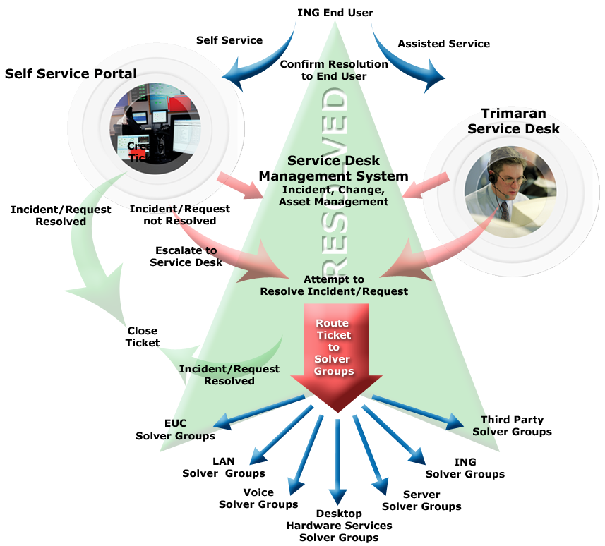

The PST Supplier Service Desk will monitor Incident duration, manage queue activity, escalate aging Incidents in accordance with procedures approved by EuroBank and assure that calls are being answered within the agreed Service Levels The Service Desk retains responsibility and ownership of an Incident and will reduce transfers to multiple Resolver Groups as much as possible. The Service Desk management system’s routing and escalation processes are periodically reviewed in accordance with the policies and procedures developed by 2IM and approved by EuroBank.

Tickets will only be closed after the Authorised User confirms the resolving of the call. After closure the Configuration and Asset Management Databases, integrated in the Service Desk Management system, are updated. A minimum sample of 10% of the calls initiated by Authorised Users is subject to a random survey immediately after using the Service Desk.

The knowledge database will continuously be updated with solutions, best practices, troubleshooting tips, escalation procedures, contact lists and other information. Updates on answers to frequently asked questions are coordinated and published on the self-help portal according to the by 2IM defined and by EuroBank approved procedures. The PST Supplier Service Desk will have dedicated staff to make sure that data makes its way from an Incident to the knowledge base and instructions are kept up-to-date (including supporting PST Supplier staff working on this across accounts). The PST Supplier will also have a number of incentive mechanisms in place to encourage knowledge publications. Call reports will be used to analyse Incidents in order to decide what knowledge is published

Reporting

The PST Supplier will provide monthly statistical and management reports on the volumes and nature of calls as defined by the 2IM and will perform trend analyses on these calls in order to identify areas for improvement. In addition client satisfaction surveys will be reported monthly.

Personnel

The PST Supplier will have an internal call assessment program to assess individual Service Desk analyst performance using a call-monitoring tool.

Service delivery quality assessments for call and ticket monitoring will use a checklist-based rating system designed to score the performance based on a specific list of weighted criteria reflecting EuroBank’s environment. Team managers and independent quality assessors will complete assessments. All scores will be retained and tracked in a quality database for further evaluation. The following ‘Best Practices’ will be used to manage the performance of the Service Desk:

• Monitor analyst performance. Analyst performance is measured both objectively and subjectively. Statistics are documented that identify metrics such as average call time, tickets closed by analyst, ticket and type by analyst. These allow the Service Desk to more accurately identify analyst strengths and weaknesses and implement any required improvement measures.

• Record analyst attendance. The PST Supplier will pay specific attention to the amount of time analysts spend on the phone. Within each 8-hour workday, analysts are active on the telephone for approximately 6 hours. The remaining time in the workday is used for non-call related activities and skills development.

• Internal quality assurance assessments. The PST Supplier will use standard call monitoring practices consisting of call recording and periodic listening to analyst calls. This allows the Service Desk to assess the quality of the service being delivered to the end user as well as the professionalism and manner in which the analyst handled the call. Service Desk coaching is provided based on the results of the review.

In order to provide fully trained Service Desk personnel with general IT skills, EuroBank knowledge and knowledge of new available products and services the PST Supplier will use skills level matrices and will have a number of training programs in place for its employees.

The Change Control process will be used to notify the PST Supplier of new banking / industry applications that require additional training being introduced. In addition trend analysis performed by the PST Supplier will highlight call trends and may identify specific banking applications that require more support calls.

Once an Application is identified by the various inputs above, training will be scheduled for Service Desk, desk side or both. This training may be coordinated with either the application vendor or existing end user training depending upon availability.

Service Management toolset

Tools to deliver equipment and software maintenance that will be used by the PST Supplier include:

• Service Desk management system is used to track Incidents and Service Requests untill successful resolution. The system interfaces with EuroBank tools and systems providing Service Desk analysts with full access to key asset management, user profile, configuration information, thereby expediting problem diagnosis.

• Kana Knowledge Management and Knowledge Explorer Web Application (KEWA) is integrated in the service delivery solution. This highly effective system has been further enhanced to provide Authorised Users and analysts with correct resolution as quickly as possible and minimum navigation. A specific example is the development of an in-house ‘front end’ to Kana that provides faster and more accurate access to resolutions, and improves the knowledge management experience. In addition, the system incorporates other enhancements such as a live information ticker, navigation history and access timers.

• SLA Manager Module provides a method for tracking performance against SLAs, managing the overall performance of Resolver Groups, to perform ad hoc and statistical analysis on tickets. SLA Manager provides a real-time view of current workload.

• Field Dispatch Systems - allows for direct assignment of field service employees and captures updates to the Incident as additional diagnosis and resolution steps are taken. It also provides parts tracking, accounting, SLA information, trend analysis, special instructions for prioritised Authorised Users, and spare parts usage activity.

• Service Portal is an Intranet/Internet enabled application that allows internal EuroBank Resolver Groups to interface directly to the Service Desk management system, creating real-time access to all Incident reports as defined by 2IM and agreed by EuroBank. This tool removes the need to install Service Desk management system software on a multitude of Resolver Group desktops. The PST Supplier will communicate with Authorised Users and EuroBank Supplier/Resolver Groups via telephone, email or the Service Portal tool as appropriate.

• I.P. Call Centre (“IPCC”) is a foundation technology and a critical component of the global service delivery model. It integrates technology enabling a virtual call centre. IPCC supports and dynamically directs multimedia Service Requests (FAX, Email, Web, Telephone) by routing to specific support skills anywhere there is high speed IP connectivity.

The locations foreseen by the PST Supplier are Antwerp (no overflow capacity for French speaking Authorised Users), Amsterdam, Budapest are options.

The PST Supplier will provide toll free numbers (where available) for all Authorised Users to access the Service Desk.

  - General
The PST Supplier’s responsibilities include:

a) Providing a SPOC for Authorised Users regarding Incidents, questions or Service Requests (ad hoc and standard service Rrequests) relating to the Services, including:

i. Providing support to Authorised Users on both a reactive and proactive basis.

ii. Providing necessary facilities, associated technologies, and fully trained personnel to respond to Calls.

iii. Providing Service Desk personnel with sufficient training on new products and services, as they become part of the PST Supplier’s responsibilities from time to time.

iv. Provisioning of Service Desk Support to at least meet standards as set by 2IM.

v. Providing and paying for a single, toll free telephone number in every country receiving the Services. Authorised Users in a particular country will use the toll free number in that country for Calls to the Service Desk.

vi. Service Desk Support (verbally and in writing) will be provided in the Agreed Languages. All other means of communication between the PST Supplier and the Authorised User will be in the local language of the Authorised User (as long as this is one of the agreed languages). Support of new languages is subject to the Change Control process.

The internal language for the PST Supplier is English. Where content on Incident tracking and tracing or knowledge management is provided to the Authorised User, this content will be presented in English only. In instances where this is not sufficient, the Authorised User can contact the Service Desk, where further support will be provided in the Agreed Languages.

b) Effectively using and implementing the capability for Authorised Users to submit Calls via electronic mail and/or a secure Website as defined by 2IM and approved by EuroBank; also continuously educating Authorised Users on the use of such media.

c) Providing and continuously updating a list of Frequently Asked Questions (FAQs) regarding the Services.

d) Publishing answers to the FAQs using media that are efficient, easy to use, and easily accessible for Authorised Users; as defined by 2IM and subject to approval by EuroBank.

e) Conducting random surveys of Authorised Users immediately after they have used the Service Desk; and reporting the results to EuroBank as defined by 2IM.

f) Performing and reporting these surveys each month and including a minimum survey sample of 10% of the Calls.

g) Calculating statistics and publishing reports monthly e.g. on the number of Calls; sources of Calls; frequency regarding the types or categories of Calls; length of open tickets; number of Calls resolved upon first contact; abandoned rate; number of Calls requiring Level 2 support; and other pertinent information regarding Calls and Incident and Problem resolution as defined by the 2IM.

h) Working to establish processes to “push” call status back to the affected Authorised User.

i) In conjunction with the 2IM, and subject to EuroBank’s review and approval, developing and periodically updating Incident and Problem escalation procedures and distributing such procedures to Authorised Users.

j) Providing Supplier Service Desk personnel who possess the appropriate skills and qualifications to provide Service Desk services.

k) Developing and documenting and implementing efficient processes regarding interfaces, interaction and responsibilities between Level 1 support personnel, Level 2 support personnel, and any other internal or external persons or entities that may either submit an Incident, or receive an Incident.

  - Call Management
The PST Supplier’s responsibilities include:
a) Receiving and logging all Calls (including submissions received by telephone, electronically e.g. web based call logging, or other means defined by 2IM and approved by EuroBank) into the call registration system. The PST Supplier will make use of overflow facilities internally when necessary to support the Call load.

b) Retaining overall responsibility and ownership of all Calls initially received at (or transferred to) the PST Supplier’s Service Desk until resolution and/or the Call is closed subject to the approval process as defined by 2IM.

c) Wherever possible, designating end-to-end responsibility for each Call to the Service Desk. Ownership of the Incident or Service Request will be driven by the Authorised User’s needs and will minimise transfers to multiple parties to the greatest extent possible.

d) Calls will be managed, using Incident numbers so updates can be communicated centrally minimising needs to transfer between multiple parties and then second parties ownership of the Incident will be determined by the Authorised Users needs.

  - For All Calls
a) Service Desk procedures regarding Calls for the initial Service Desk support person should include:

i. Making an initial determination of the potential resolution.

ii. Providing or coordinating the final resolution (as described below).

iii. Providing tracking and reporting.

b) Utilizing and updating the Incident Management system with all relevant information relating to a Call.

  - For Calls that relate to the Services
a) Service Desk procedures regarding Calls that relate to the Services should include:

i. Logging the Call and opening a ticket in the Incident Management system.

ii. Resolving Calls requiring Level 1 support and closing the ticket after receiving confirmation from the affected Authorised User that the Call has been resolved.

b) If the Call requires Level 2 support:

i. Routing the ticket to the appropriate Resolver Group for resolution.

ii. Tracking the progress of resolution efforts.

iii. Escalating Incidents to the appropriate levels for resolution in accordance with escalation procedures approved by EuroBank.

iv. Closing a ticket after receiving confirmation from the affected Authorised User that the Call has been resolved.

  - For Calls that do not arise from or relate to the Services
a) Service Desk procedures regarding Calls that do not arise from or relate to the Services should include:

i) Logging the Call and opening a ticket in the Incident Management system, and then:

ii) Routing the ticket to the appropriate Resolver Group for resolution or the retained organisation in the absence of a clearly defined Resolver Group. The retained organisation will then assign the ticket to the right Resolver Group and update the definition of Resolver Groups when appropriate.

iii) Tracking the progress of resolution efforts.

iv) Escalating Incidents to the appropriate levels for resolution in accordance with escalation procedures as defined by 2IM.

v) Closing a ticket after receiving confirmation from the affected Authorised User that the Call has been resolved.

b) Acting proactively and cooperating fully with all other internal or external parties to resolve the Call.

